# Multithreading – Thread Parameter passing and Return Handling assignments

**Mandatory**

1. Create a multithreaded program to
2. read 3 lines as a single command line argument
3. extract every line and pass it to a thread.
4. each thread should sort all the words in the line in ascending order and return sorted line to the main thread
5. main thread to wait for all child threads to complete, then read and display the sorted line ”.
6. Release any allocated memory

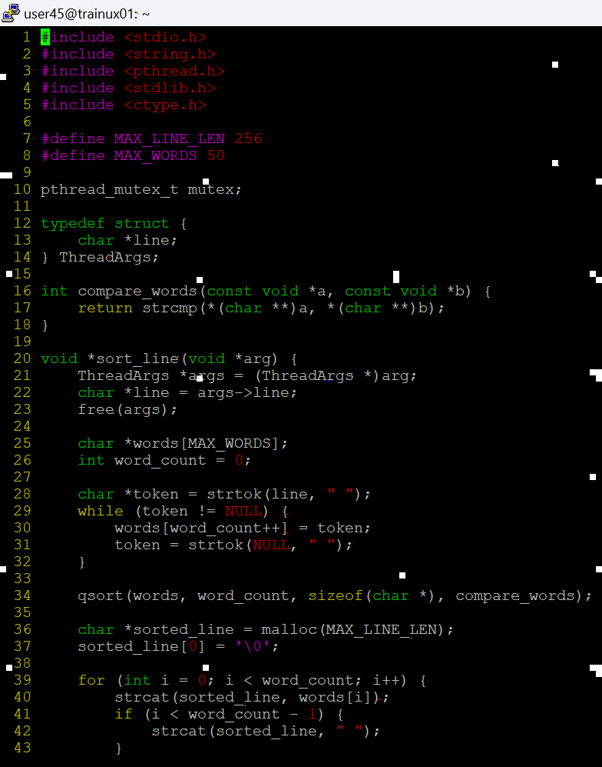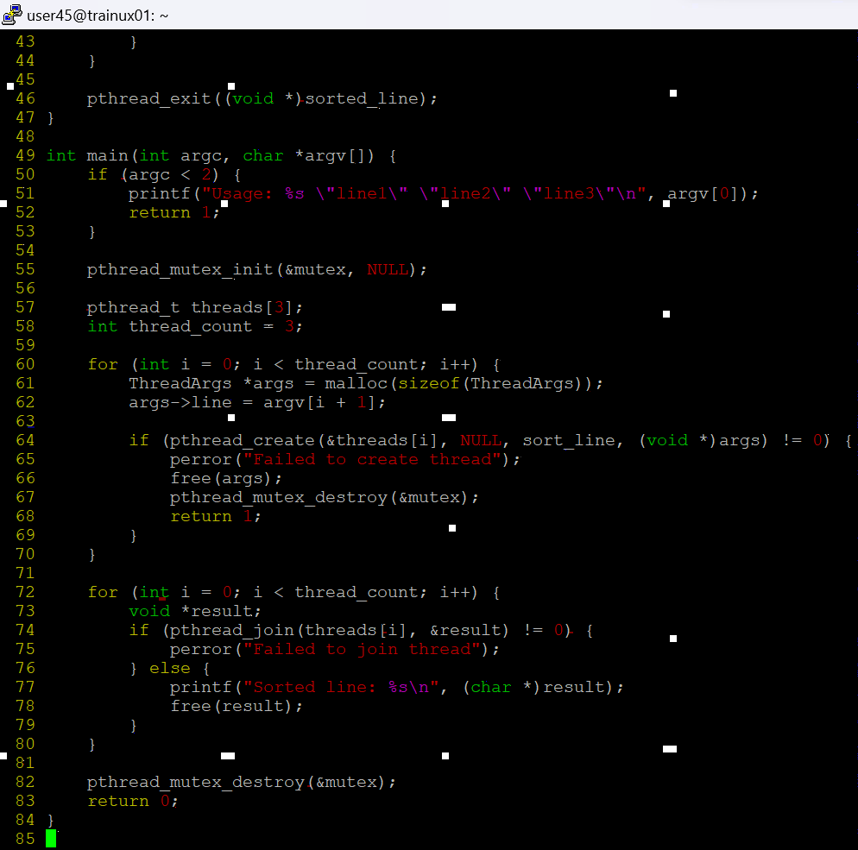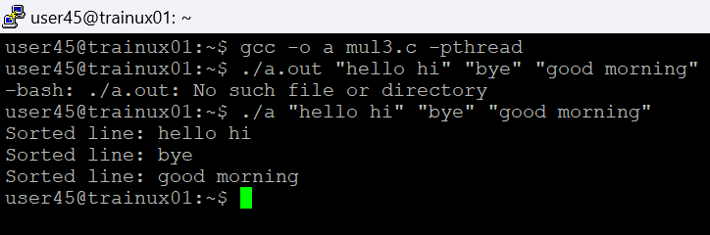

1. Write a program to read a file name, to read lines , process it using two or more threads (i.e one thread/line) to count and display the words in the line. For this implement functions below, integrate and test solution.

//receive thread count as argument, create an array of pthread_t (double pointer allocated memory in heap) and return pointer

a) createthreads()

//to receive filename, thread array as args, process each line using a thread function

b) process_file()

//receive a line as input, count words and display, return line and word count to parent thread in a structure

c) thread_proc()

Ensure that there are no memory leaks

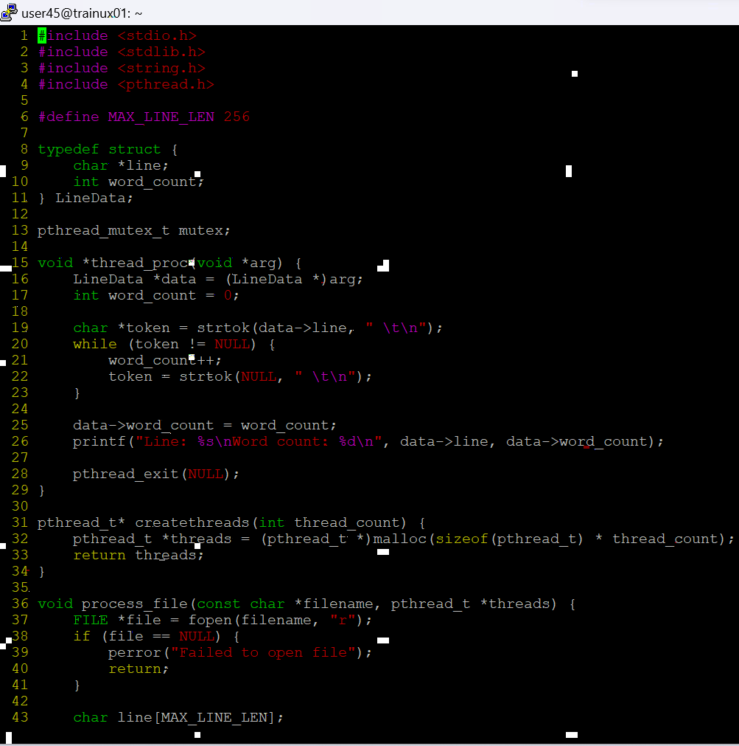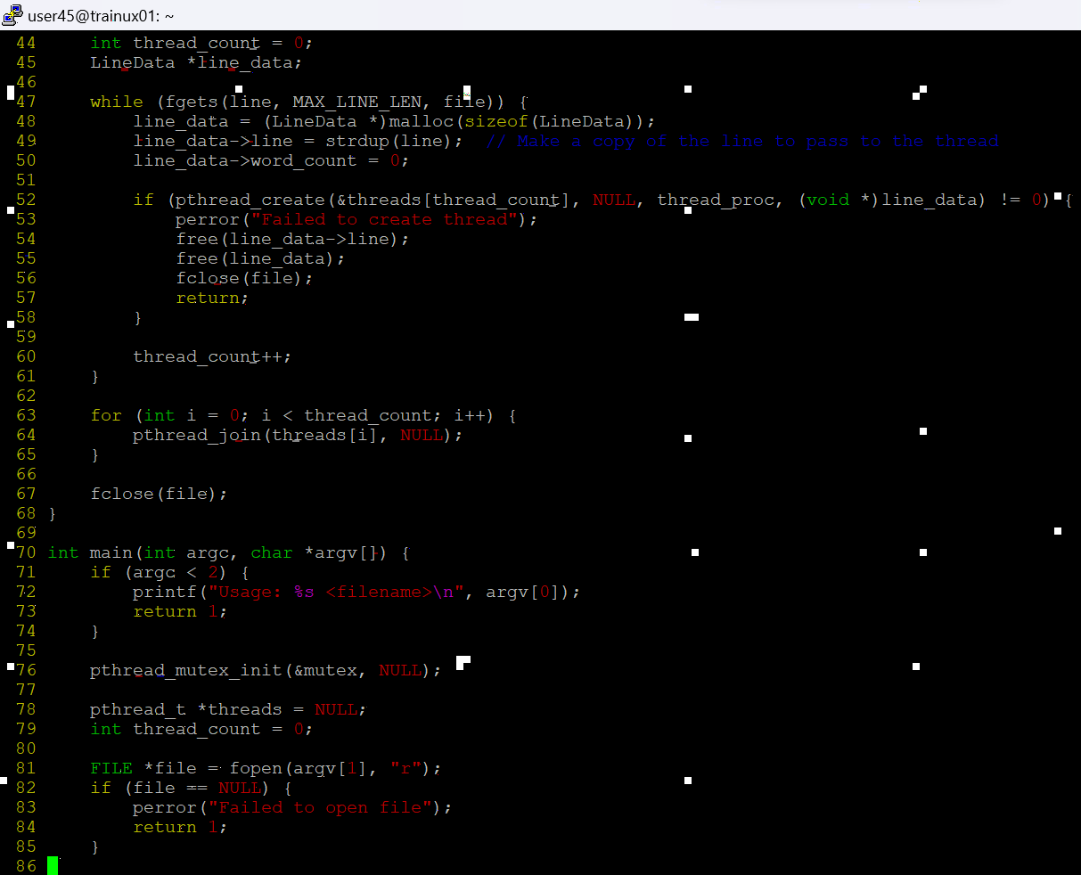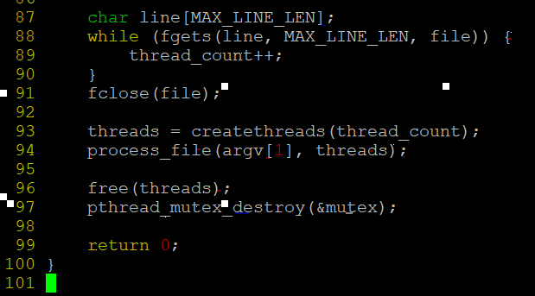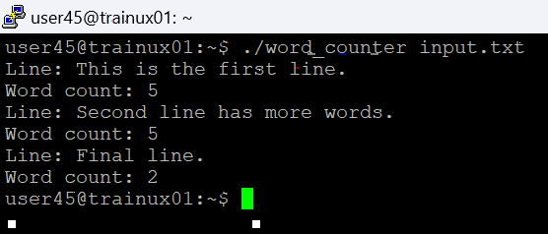

1. In github or from other source, check for thread program related source code , download and test it, place the code and test cases executed with outputs. Understand , should be able to do a walkthrough in next session.